# Note: This is an older version of the labs for this class. There is a lot of helpful material here, but you do not need to submit anything regarding this document.

# Intro to LCA: Practice 1

**Outline**

1. Why use **MplusAutomation R package**, is it worth the trouble?
   1. Compared to doing in R
   2. Or entirely in Mplus
2. Demonstrate the enumeration example using MplusAutomation
3. Review the Mplus & R BASICS handouts
4. Use the R script, template file, and PDF handout in the Lab 1 folder to run the example on your own computer.

**Practicing LCA enumeration using MplusAutomation in R:**

**Applied Example: Positive Youth Development Inventory Analysis**

We will replicate the LCA illustrated in the following 2018 article published in, Translational Issues in Psychological Science

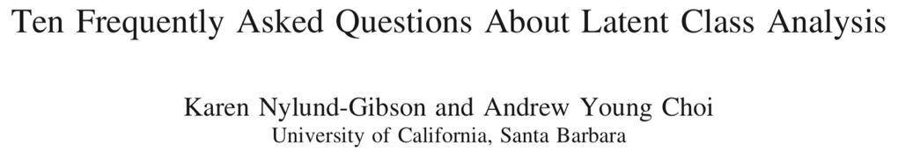

The indicators used in the LCA are from the Positive Youth Development Inventory (PYDI) Contribution subscale (Arnold, Nott, & Meinhold, 2012). The data was collected from 1,629 college students in the Santa Barbara by GGSE’s CoVitality lab.

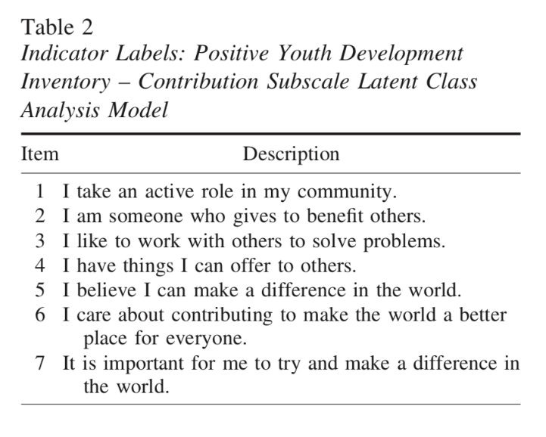

**Step 1 – Organization**

* Create a folder on your computers desktop (e.g. “lab_1”) with a subfolder inside titled “mplus_lab1”.
* From GauchoSpace download the Lab 1 template file (.txt), the data file (PYDI.dat), the R script file (.R), and the Lab 1 handout (.pdf).
* Put all the files in the folder you created on your desktop.
* Move the data file, PYDI.dat, into the subfolder “mplus_lab1”

**Step 2 – Edit the template file [[/init]] section.**

* Add the appropriate **file-path**
* Check that the **iterator** line of code will create the desired set of models.
* Add the iterator command in the following places (as shown in the PDF handout):
  + Specify the iterator name, and values it should iterate
  + Add the iterator command into the **filename** code. This tells Mplus how to name the input files.
  + Add the iterator command into the **title**
  + Add the iterator command into the syntax which specifies the number of classes
* Edit the file-path line of code to reflect the location of the folder you created called **mplus_lab1**

**Step 3 – run Mplus automation, follow the steps from the PDF Lab 1 handout.**

* Generate the 3-class plot in R using ggplot2
* Try generating the 4-class plot, does it replicate the Nylund-Gibson, & Choi (2018) figure? This will require changing the R code in a couple of places. Ask for help!

**Step 4 – locate the following parameters from the 3-Class Mplus output file**

1. Locate the following in the output file:
   1. Total analysis sample size.
   2. Number of free parameters.
   3. Observed item response counts and proportions.
   4. Final class counts and proportions based on the estimated model.
   5. Model-estimated item thresholds for each class.
   6. Latent class multinomial logit means (class proportion/size).
   7. Class-specific item response probabilities.
2. Thinking of this in terms of a latent variable measurement model, which parameters are “measurement parameters” and which parameters are “structural parameters”?

Mplus gives you a message similar to the following:

IN THE OPTIMIZATION, ONE OR MORE LOGIT THRESHOLDS APPROACHED AND WERE SET

AT THE EXTREME VALUES. EXTREME VALUES ARE -15.000 AND 15.000.

THE FOLLOWING THRESHOLDS WERE SET AT THESE VALUES:

* THRESHOLD 1 OF CLASS INDICATOR CA28GR FOR CLASS 2 AT ITERATION 69

Locate the message this message in your output file. Any thoughts on what it means?